1)Define the Islamic political system and discuss the main principles with proper evidence from the Quran and Sunnah. ( Sp-22,sp-23, Au-23)

Ans:



The Islamic political system is a system of governance based on principles derived from the teachings of Islam, primarily from the Quran (the holy book of Islam) and the Sunnah (the recorded traditions and practices of the Prophet Muhammad). This system encompasses various aspects of governance, including the structure of authority, the rule of law, justice, consultation, and accountability.

1. **Sovereignty of Allah (Tawheed)**:
   * The Quran emphasizes the concept of Tawheed, which asserts the absolute sovereignty of Allah. In matters of governance, this principle implies that ultimate authority rests with Allah alone, and humans are required to govern in accordance with His divine guidance.
   * Quranic evidence: "Say, 'He is Allah, [who is] One, Allah, the Eternal Refuge. He neither begets nor is born, nor is there to Him any equivalent.'" (Quran, Surah Al-Ikhlas, 112:1-4)
2. **Justice and Equity**:
   * Islamic political theory stresses the importance of justice and equity in governance. Leaders are expected to uphold justice for all individuals, regardless of their social status or background.
   * Quranic evidence: "O you who have believed, be persistently standing firm in justice, witnesses for Allah, even if it be against yourselves or parents and relatives. Whether one is rich or poor, Allah is more worthy of both." (Quran, Surah An-Nisa, 4:135)
3. **Consultation (Shura)**:
   * The principle of Shura emphasizes consultation and deliberation in decision-making processes. It encourages leaders to seek the opinions and advice of those affected by their decisions.
   * Quranic evidence: "And those who have responded to their lord and established prayer and whose affairs are [settled by] consultation among themselves, and from what We have provided them, they spend." (Quran, Surah Ash-Shura, 42:38)
4. **Rule of Law**:
   * Islamic political system advocates for the rule of law, where all individuals, including leaders, are subject to the law. No one is above the law, and justice must be administered impartially.
   * Quranic evidence: "O you who have believed, be persistently standing firm for Allah, witnesses in justice, and do not let the hatred of a people prevent you from being just. Be just; that is nearer to righteousness. And fear Allah; indeed, Allah is Acquainted with what you do." (Quran, Surah Al-Maidah, 5:8)
5. **Accountability**:
   * Leaders in the Islamic political system are accountable to both Allah and the people they govern. They are responsible for their actions and decisions, and they will be judged accordingly.
   * Hadith evidence: The Prophet Muhammad (peace be upon him) said, "All of you are shepherds, and each one is responsible for his flock. A leader of the people is a shepherd and responsible for his subjects." (Sahih al-Bukhari, Sahih Muslim)

These principles collectively form the basis of the Islamic political system, aiming to establish a just, equitable, and accountable governance framework in accordance with the teachings of Islam.

2)WHAT IS SHARIAH? EXPLAIN THE SUPREMACY OF SHARIAH IN THE ISLAMIC CONSTITUTION. Analyze sources of Shariah with some examples

Ans:

Shariah, often referred to as Islamic law, is a comprehensive system of moral, ethical, and legal principles derived from the Quran (the holy book of Islam), the Sunnah (the teachings and practices of the Prophet Muhammad), and the consensus of Islamic scholars. It governs various aspects of a Muslim's life, including personal conduct, family matters, commerce, politics, and governance. Shariah is considered by Muslims to be the divine law of Allah, guiding believers on the path of righteousness and justice.

The supremacy of Shariah in an Islamic constitution refers to the principle that Shariah holds the highest authority in matters of law and governance within a state or society governed by Islamic principles. This principle is based on the belief that Shariah represents the perfect and immutable guidance of Allah, and as such, it should serve as the ultimate source of legislation and jurisprudence.

Here are some key aspects explaining the supremacy of Shariah in an Islamic constitution:

1. **Source of Authority**: Shariah derives its authority directly from Allah as revealed in the Quran and through the teachings and actions of the Prophet Muhammad. It is considered divine law and, therefore, superior to any man-made laws or systems.
2. **Comprehensive Guidance**: Shariah provides comprehensive guidance on all aspects of life, including personal morality, family relations, economic transactions, criminal justice, and governance. It offers principles and guidelines that govern both individual behavior and societal institutions.
3. **Integration with State Laws**: In an Islamic constitution, Shariah is integrated into the legal framework of the state. This means that laws and policies must be consistent with Shariah principles and objectives. While some aspects of Shariah may be codified into law, others may be interpreted and applied by Islamic scholars and jurists based on the context and circumstances.
4. **Principles of Justice and Equity**: Shariah emphasizes principles of justice, equity, and compassion. Its application in governance aims to ensure fairness, protection of rights, and welfare for all members of society, regardless of their backgrounds or beliefs.
5. **Consultation and Consensus**: Islamic governance systems often incorporate principles of consultation (Shura) and consensus-building among leaders and stakeholders. This ensures that decisions and policies align with Shariah principles and enjoy broader societal acceptance.
6. **Judicial Review**: In an Islamic constitution, judicial review is conducted to ensure that laws and actions of the government comply with Shariah principles. Courts may invalidate laws or government actions deemed incompatible with Shariah.
7. **Dynamic Interpretation**: Shariah is not static but subject to interpretation and adaptation based on changing circumstances and societal needs. Islamic scholars and jurists engage in ongoing interpretation (Ijtihad) to derive rulings and guidance applicable to contemporary issues.

In summary, the supremacy of Shariah in an Islamic constitution reflects the belief that it represents the divine will of Allah and serves as the ultimate source of guidance for individuals and societies. It provides a framework for governance that is grounded in justice, equity, and morality, with the aim of fostering a just and virtuous society.

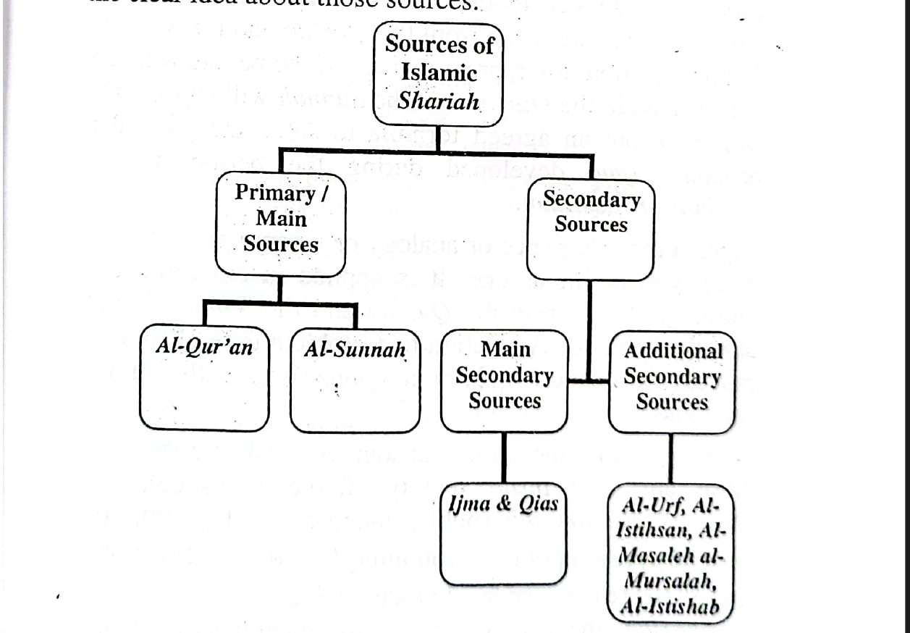

The sources of Shariah, also known as Usul al-Fiqh (principles of Islamic jurisprudence), provide the foundational framework for deriving legal rulings and guidance in Islam. These sources are primarily derived from the Quran, the Sunnah (Prophetic traditions), Ijma (consensus of Islamic scholars), Qiyas (analogical reasoning), and Ijtihad (independent legal reasoning). Let's analyze each of these sources with examples:

1. **The Quran (Al-Kitab)**:
   * The Quran is the primary and fundamental source of Shariah. It is believed to be the literal word of Allah as revealed to the Prophet Muhammad over a period of approximately 23 years.
   * Examples: Direct legal injunctions found in the Quran include the prohibitions against murder (Quran 17:33), theft (Quran 5:38), and interest-based transactions (Quran 2:275-279).
2. **The Sunnah**:
   * The Sunnah refers to the actions, sayings, approvals, and disapprovals of the Prophet Muhammad. It provides practical implementation and elaboration of the principles outlined in the Quran.
   * Examples: The method of performing prayers, fasting, and pilgrimage (Hajj) are derived from the Sunnah. For instance, the number of units (Rak'ahs) in each prayer and the manner of performing ablution (Wudu) are based on the Prophet's teachings.
3. **Ijma (Consensus)**:
   * Ijma refers to the consensus of Islamic scholars on matters not explicitly addressed in the Quran and Sunnah. It is considered a source of authority in Islamic law, representing the collective wisdom of the scholarly community.
   * Example: The consensus among scholars on the prohibition of consuming intoxicants, even though the Quranic verses addressing the issue do not explicitly mention all forms of intoxicants.
4. **Qiyas (Analogical Reasoning)**:
   * Qiyas involves the application of legal rulings from existing sources (Quran, Sunnah, and Ijma) to new situations that may not have been addressed directly in those sources, but share similar underlying principles.
   * Example: Extending the prohibition of intoxicants to substances not explicitly mentioned in the Quran or Sunnah, based on their shared characteristic of intoxication.
5. **Ijtihad (Independent Legal Reasoning)**:
   * Ijtihad refers to the process of independent legal reasoning conducted by qualified scholars (Mujtahids) to derive legal rulings when existing sources do not provide clear guidance.
   * Example: Addressing contemporary issues such as bioethics, financial transactions, and technology, where specific rulings are not found in classical sources, requires Ijtihad to derive applicable principles.

3)Describe Islamic constitution and describe its special features of it

Ans:

An Islamic constitution is a framework for governance based on the principles and values of Islam, incorporating Islamic law (Shariah) as the primary source of legislation and guidance. While there is no single model for an Islamic constitution due to the diversity of interpretations and practices within the Muslim world, there are common features and principles that are often found in such constitutions. Below are descriptions of the special features of an Islamic constitution:

1. **Recognition of Shariah as the Primary Source of Law**:
   * One of the defining features of an Islamic constitution is the recognition of Shariah as the primary source of legislation. Shariah principles guide the formulation and interpretation of laws, with the Quran and Sunnah serving as fundamental sources of guidance.
2. **Sovereignty of Allah and the Rule of Law**:
   * Islamic constitutions typically affirm the sovereignty of Allah and recognize Him as the ultimate authority. At the same time, they emphasize the rule of law, ensuring that all individuals, including rulers and government officials, are subject to the law and accountable for their actions.
3. **Protection of Fundamental Rights**:
   * Islamic constitutions often guarantee the protection of fundamental rights and freedoms, such as the right to life, liberty, property, equality before the law, and freedom of religion. These rights are considered inherent and are safeguarded within the framework of Islamic law.
4. **Institutions of Islamic Governance**:
   * Islamic constitutions may establish specific institutions to uphold Islamic principles in governance, such as a council of Islamic scholars (Shura) to advise on matters of legislation and policy, or a Supreme Court with jurisdiction over Shariah matters.
5. **Recognition of Diversity and Pluralism**:
   * Islamic constitutions often recognize the diversity of Muslim communities and the need to accommodate different interpretations and schools of thought within Islam. They may provide mechanisms for resolving disputes and accommodating religious minorities while upholding the principles of justice and equality.
6. **Social Welfare and Economic Justice**:
   * Islamic constitutions frequently emphasize principles of social welfare and economic justice, including the prohibition of usury (riba), the promotion of charity (zakat), and measures to address poverty and inequality.
7. **Integration of Modern Governance Principles**:
   * While grounded in Islamic principles, Islamic constitutions may integrate modern governance principles such as democracy, accountability, and transparency. They may include provisions for free and fair elections, separation of powers, and mechanisms for checks and balances.
8. **Flexibility and Adaptability**:
   * Islamic constitutions often exhibit flexibility and adaptability to accommodate changing circumstances and societal needs. They may provide mechanisms for interpretation (Ijtihad) and revision to ensure relevance and effectiveness in contemporary contexts.

In summary, an Islamic constitution combines principles of Islamic law with modern governance practices to establish a framework for governance that is grounded in justice, equality, and the sovereignty of Allah. It seeks to uphold Islamic values while addressing the needs and aspirations of diverse Muslim societies.

4)Discuss 3 fundamental elements of Islamic political networks and differentiate between Islamic and conventional systems of politics

Ans:

Islamic political networks, which are rooted in the principles of Islam, have distinct fundamental elements that differentiate them from conventional political systems. Three key elements of Islamic political networks are:

1. **Religious Authority and Guidance**:
   * In Islamic political networks, religious authority plays a central role in guiding governance and decision-making processes. Islamic scholars and jurists often provide guidance on matters of law and policy based on interpretations of Shariah (Islamic law) derived from the Quran, Sunnah, and other sources.
   * Religious leaders may exert influence through fatwas (legal opinions), sermons, and religious education, shaping public opinion and influencing political discourse. Their role is to ensure that governance aligns with Islamic principles and values.
2. **Community Engagement and Consultation**:
   * Islamic political networks emphasize the importance of community engagement and consultation (Shura) in decision-making processes. Leaders are encouraged to seek the input and consensus of the community, reflecting principles of democratic participation and inclusivity.
   * Decision-making is often decentralized, with grassroots organizations, community leaders, and religious institutions playing active roles in governance and social welfare initiatives. This fosters a sense of community ownership and empowerment.
3. **Integration of Moral and Ethical Principles**:
   * Islamic political networks integrate moral and ethical principles into governance, emphasizing justice, equity, compassion, and accountability. Leaders are expected to govern with integrity, fairness, and a commitment to the welfare of all members of society.
   * Policies and laws are evaluated based on their adherence to Islamic ethics, with a focus on addressing social injustices, poverty, and inequality. Islamic political networks prioritize the well-being of the collective over individual interests, promoting social cohesion and solidarity.

Now, let's differentiate between Islamic political networks and conventional political systems:

1. **Basis of Authority**:
   * Islamic political networks derive authority from religious sources and principles, with religious leaders often playing influential roles in governance. In contrast, conventional political systems typically derive authority from secular sources such as constitutions, laws, and democratic processes, with elected officials holding political power.
2. **Decision-Making Processes**:
   * Islamic political networks emphasize community engagement, consultation, and adherence to Islamic principles in decision-making. In conventional political systems, decision-making processes may be more centralized, with elected representatives or government officials making decisions based on political ideologies, interests, and electoral mandates.
3. **Role of Religion**:
   * Religion plays a central role in shaping governance and policy in Islamic political networks, with adherence to Islamic law (Shariah) guiding legislation and governance. In contrast, religion is typically separated from the state in conventional political systems, with secularism or religious pluralism ensuring the separation of religious institutions from governmental affairs.
4. **Ethical Framework**:
   * Islamic political networks integrate moral and ethical principles into governance, prioritizing justice, equity, and compassion. In conventional political systems, while ethical considerations may inform governance, decision-making is often guided by legal frameworks, political ideologies, and pragmatic considerations.

Overall, while both Islamic and conventional political systems aim to govern societies and address the needs of their citizens, they differ in their foundations of authority, decision-making processes, role of religion, and ethical frameworks. Islamic political networks prioritize adherence to Islamic principles and values, community engagement, and the integration of religious authority into governance, distinguishing them from conventional political systems.

5)WHAT IS THE QURANIC AND SUNNATIC TERM FOR THE CHIEF EXECUTIVE. DESCRIBE HIS QUALIFICATIONS WITH PROPER ARGUMENTS

Ans:

In the Quran and Sunnah, the term used for the chief executive or leader is primarily "Amir" or "Imam". These terms are used to refer to a leader or ruler who holds authority over a community or group of people. The qualifications for such a leader can be inferred from various Quranic verses and Prophetic traditions, which emphasize qualities such as piety, justice, wisdom, and consultation.

1. **Piety (Taqwa)**:
   * The Quran emphasizes the importance of piety and righteousness in leadership. A leader should fear Allah and adhere to His commandments, acting with integrity and sincerity in all matters.
   * Quranic evidence: "Indeed, Allah commands you to render trust to whom they are due and when you judge between people to judge with justice. Excellent is that which Allah instructs you. Indeed, Allah is ever Hearing and Seeing." (Quran, Surah An-Nisa, 4:58)
2. **Justice (Adl)**:
   * Justice is a fundamental principle in Islam, and a leader must uphold justice for all members of society, regardless of their background or status. This includes ensuring equality before the law and protecting the rights of individuals.
   * Quranic evidence: "O you who have believed, be persistently standing firm in justice, witnesses for Allah, even if it be against yourselves or parents and relatives. Whether one is rich or poor, Allah is more worthy of both. So follow not [personal] inclination, lest you not be just. And if you distort [your testimony] or refuse [to give it], then indeed Allah is ever, with what you do, Acquainted." (Quran, Surah An-Nisa, 4:135)
3. **Wisdom (Hikmah)**:
   * A leader should possess wisdom and sound judgment in decision-making, considering the long-term consequences of their actions and policies. Wisdom enables a leader to navigate complex situations and challenges effectively.
   * Quranic evidence: "And We gave to David, Solomon [his son] - an excellent servant, indeed he was one repeatedly turning back [to Allah]. [Mention] when there were exhibited before him in the afternoon the poised [standing] racehorses. And he said, 'Indeed, I gave preference to the love of good [things] over the remembrance of my Lord until the sun disappeared into the curtain [of darkness].' [He said], 'Return them to me,' and set about striking [their] legs and necks." (Quran, Surah Sad, 38:30-33)
4. **Consultation (Shura)**:
   * The Quran encourages leaders to consult with their advisors and the community in decision-making processes. Consultation fosters inclusivity, and consensus-building, and ensures that decisions reflect the collective will of the people.
   * Quranic evidence: "And those who have responded to their lord and established prayer and whose affair is [determined by] consultation among themselves, and from what We have provided them, they spend." (Quran, Surah Ash-Shura, 42:38)

These qualifications emphasize the importance of selecting leaders who possess moral integrity, wisdom, justice, and consultation skills. A leader who embodies these qualities can effectively govern with the welfare and prosperity of the community in mind, fulfilling the responsibilities entrusted to them by Allah and the people.